Empathy Map Canvas

*Version:*

*Date:*

*Designed by:*

*Designed for:*

1 **WHO** are we empathizing with?

*Villagers/common man who have a desire to know the quality of water.

*people who are dependent on river water for survival

*Those people who live in regions nearby the river.

*Industrial Owners/Authorities.

What do they need to **DO**?

2 *They expect extra features from the product.

**GOAL**

*The device need to show accurate results.

*The feature provided must be unique and good enough to solve the problem.

*By consistently obtaining accurate results, we can confirm the efficiency of the system.

# PAINS

7 What do they **THINK** and **FEEL**?

# GAINS

3 What do they **SEE**?

*They might come across a better

What do they **HEAR**?

*They hear about many technical features for monitoring Water quality

*They hear many feedbacks by other customer over the same product

*They hear about various other company products and how other products are able to give competition to our product.

What are their fears, frustrations, and anxieties?

* Whether the app might display wrong information from sensor output.
* The product might not alert the user on time and user may consume the dirty water.
* Anxieties and fear regarding health loss, after drinking unfit drinking water.

What are their wants, needs, hopes and dreams?

1. Every user needs an product with effective and easy user interface.
2. User needs the app to display more details.
3. They hope to receive service when requested.

product.

*They might read articles regarding the price of similar products

*They see their colleagues/Friends use different sensors to monitor the parameters.

4 What do they **SAY**?

* + We want a reliable App to monitor water quality.
  + We want a better Graphical interface in application for better understanding and Viewability.
  + We want to App Services to be provided free of cost.
  + The App must be open source and do not contain any

A feeling of security and safety can be assured or induced in the user’s mind, once they know that the product is showing precise results and therefore they can be relieved by the fact that they will be notified at the time when water is dirty or turbid.

bugs.

5 What do they DO?

*They compare and discuss the features offered by

other products.

*They check the effectiveness of the sensor outputs with manual testing, and observe the accuracy.

Last updated on 16 July 2017. Download a copy of this canvas at <http://gamestorming.com/empathy-map/>

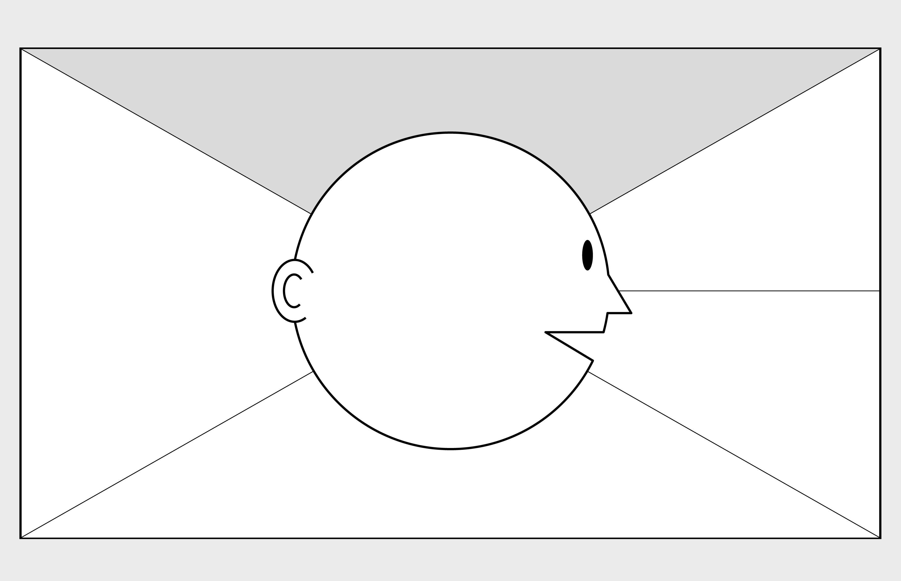

© 2017 Dave Gray,

xplane.com